Meta Ads Campaign Plan – Star Insurance Company
Star Insurance Company - Leads campaign - 25 Dec 2025
Campaign Goal:
Generate quality inquiries for Health Insurance in India.
Budget: ₹25,000
Duration: 15 Days
1. Competitor Research (3 Competitors)
- HDFC ERGO Health Insurance
- Max Bupa Health Insurance
- Star Health & Allied Insurance
2. Unique Selling Points (USPs) – Health Insurance
- Cashless Treatment at Network Hospitals
- Comprehensive Coverage
- Affordable Premium Plans
- Fast & Digital Claim Process
- No-Claim Bonus Benefits
3. Campaign Setup – Meta Ads Manager
a) Selected Objective
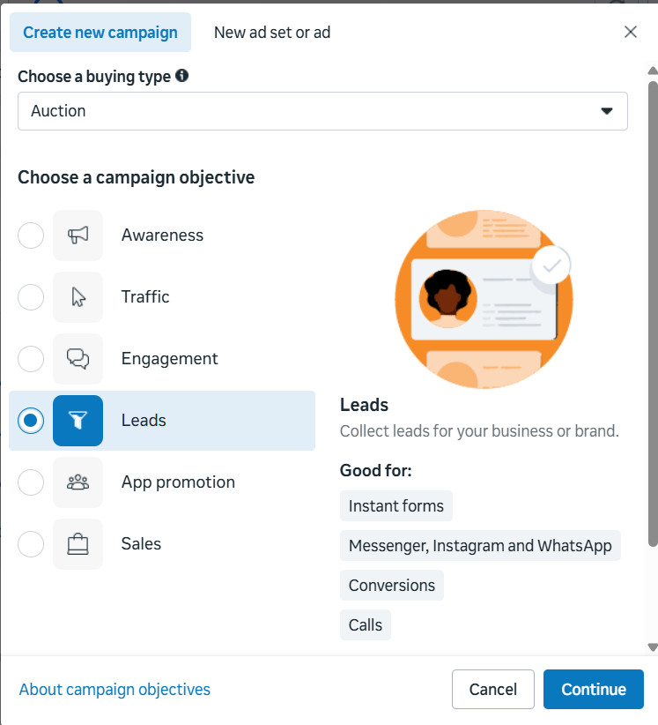
b) Budget Setup
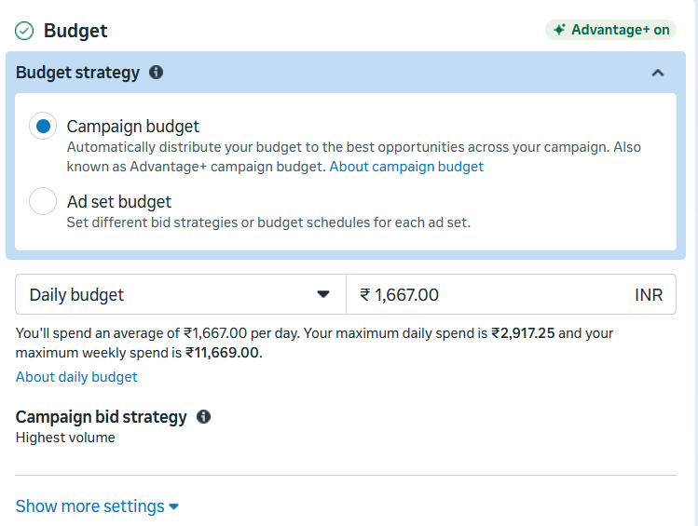
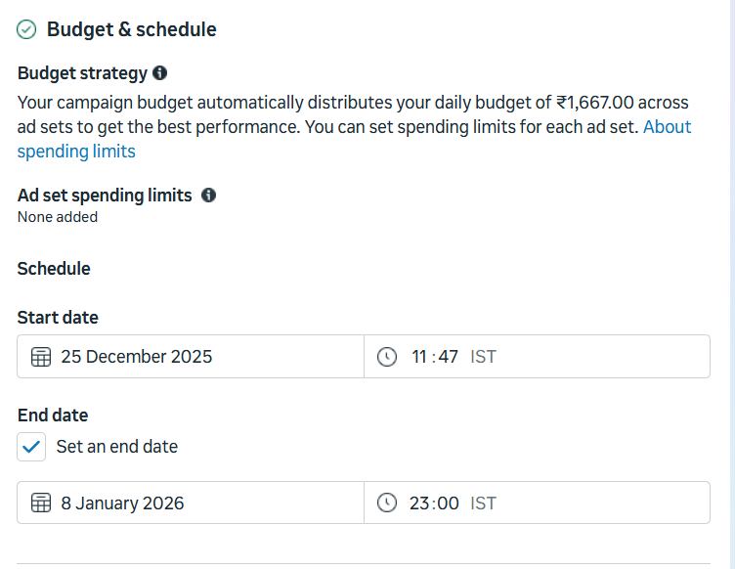
c) Audience Targeting
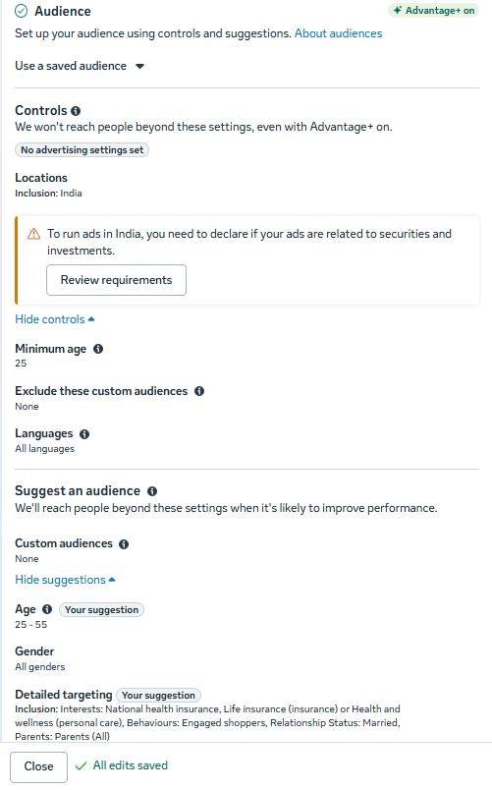
d) Placement Selection
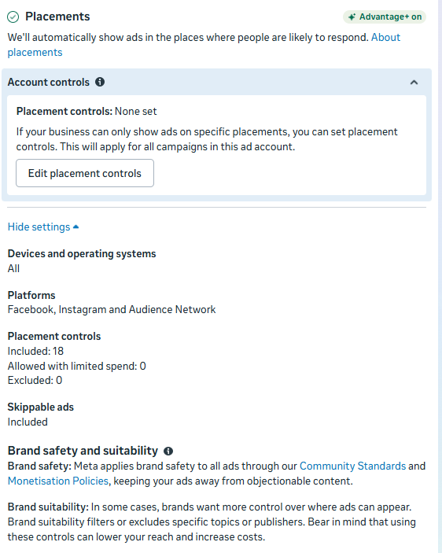
e) Ad Preview
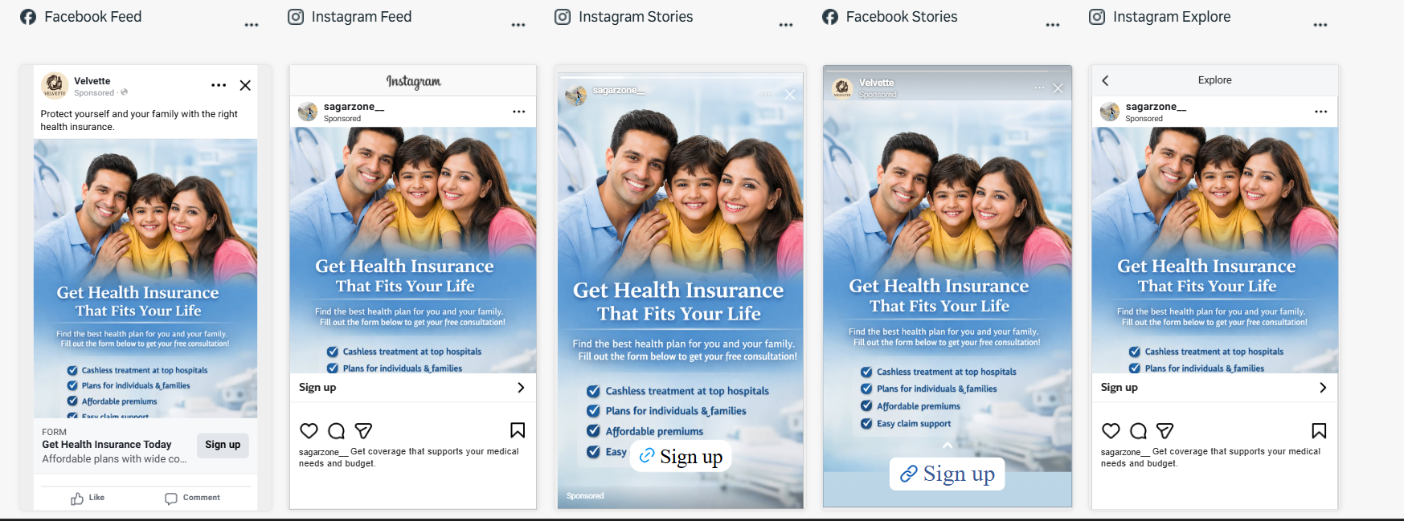
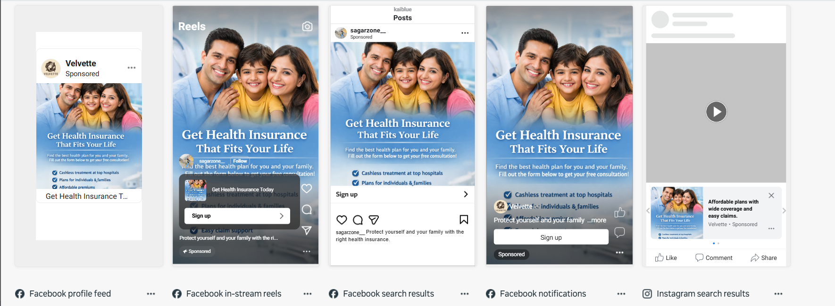
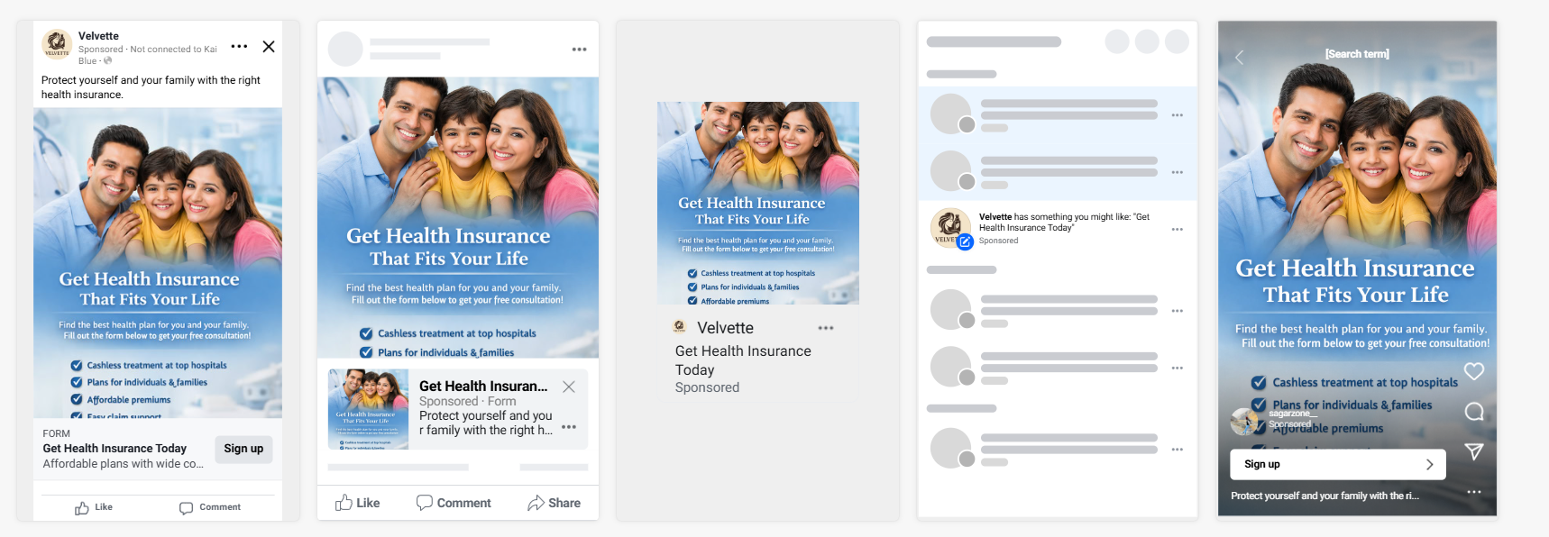
f) Lead Form Created
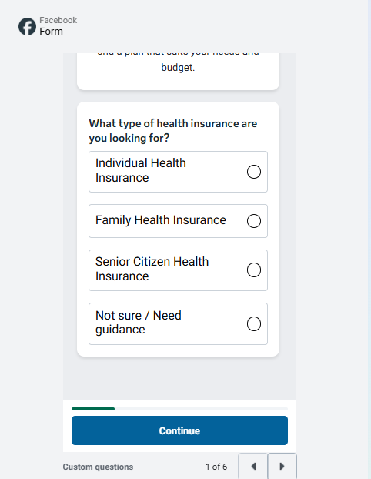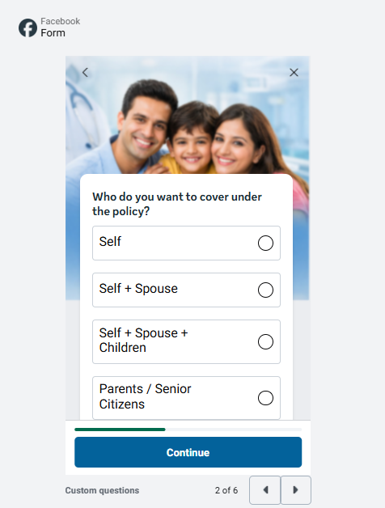
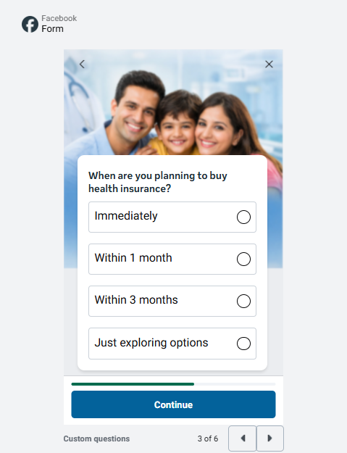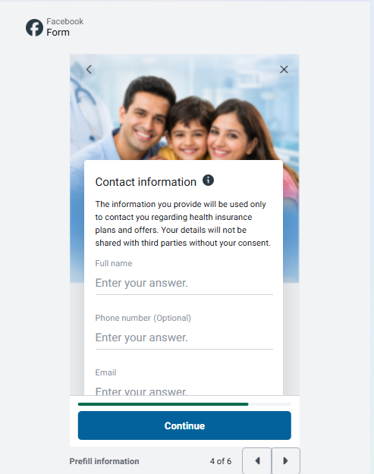
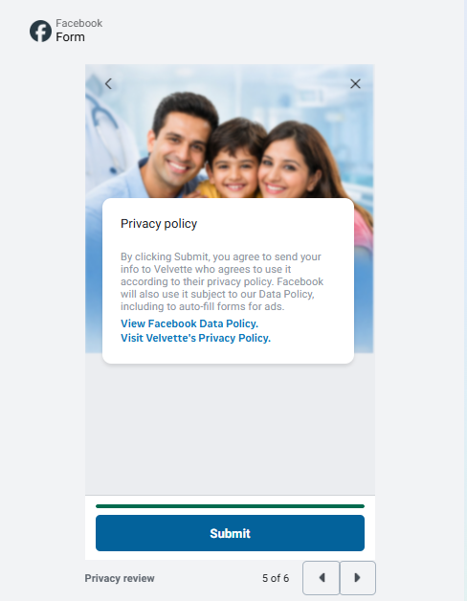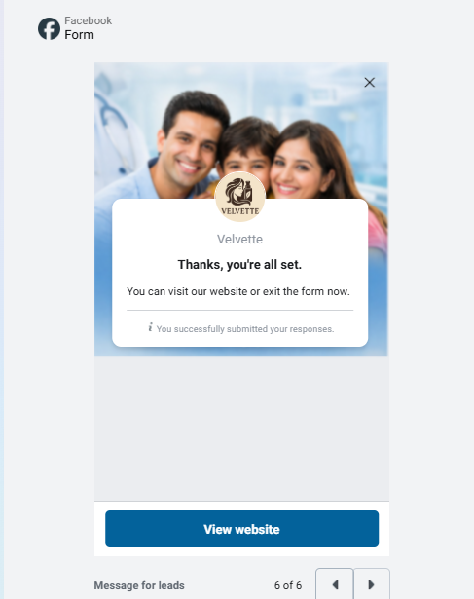
g) Estimated Campaign Results
